Write a C program to find the eligibility of admission for a professional course based on the following criteria:

Marks in Maths >= 65

Marks in Physics >= 55

Marks in Chemistry >= 50

Or

Total in all three subjects >= 180

**Sample Test Cases**

**Test Case 1**

**Input**

 70   60   80

**Output**

The candidate is eligible

**Test Case 2**

**Input**

50   80   80

**Output**

The candidate is eligible

**Test Case 3**

**Input**

50   60   40

**Output**

The candidate is not eligible

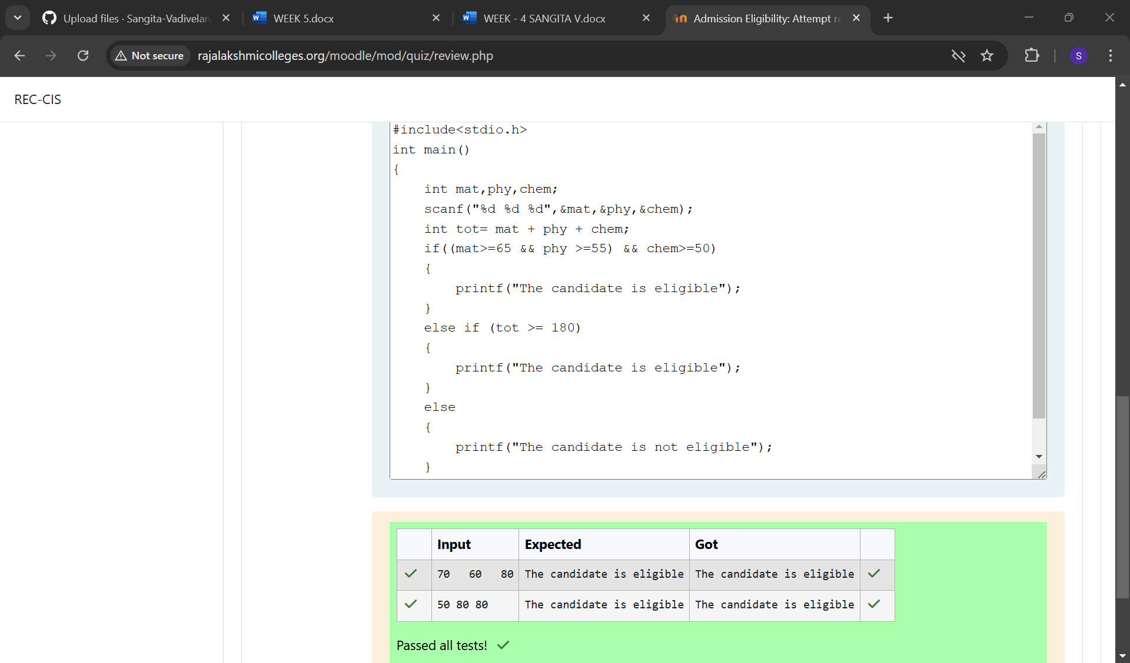

Complete the calculator program with Basic operations (+, -, *, /, %) of two numbers using switch statement.

**Sample Test Cases**

**Test Case 1**

**Input**

45

45

+

**Output**

Result: 45 + 45 = 90.000000

**Test Case 2**

**Input**

56

8

%

**Output**

Result: 56 % 8 = 0.000000

**Test Case 3**

**Input**

50

70

$

**Output**

Invalid operation.

Result: 50 $ 70 = 0.000000

**Test Case 4**

**Input**

5

2

/

**Output**

Result: 5 / 2 = 2.500000

**For example:**

| **Input** | **Result** |
| --- | --- |
| 5  2  / | Result: 5 / 2 = 2.500000 |

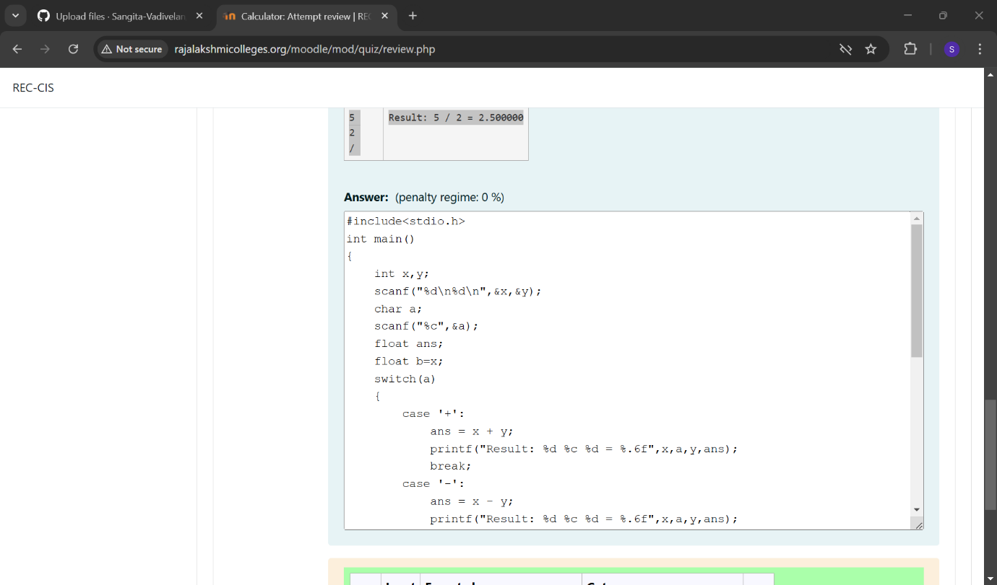

You are given a sequence of integers as input, terminated by a -1. (That is, the input integers may be positive, negative or 0. A -1 in the input signals the end of the input.)

-1 is not considered as part of the input.

Find the second largest number in the input. You may not use arrays.

**Sample Test Cases**

**Test Case 1**

**Input**

-840 -288 -261 -337 -335 488 -1

**Output**

-261

**Test Case 2**

**Input**

-840 -335 -1

**Output**

-840

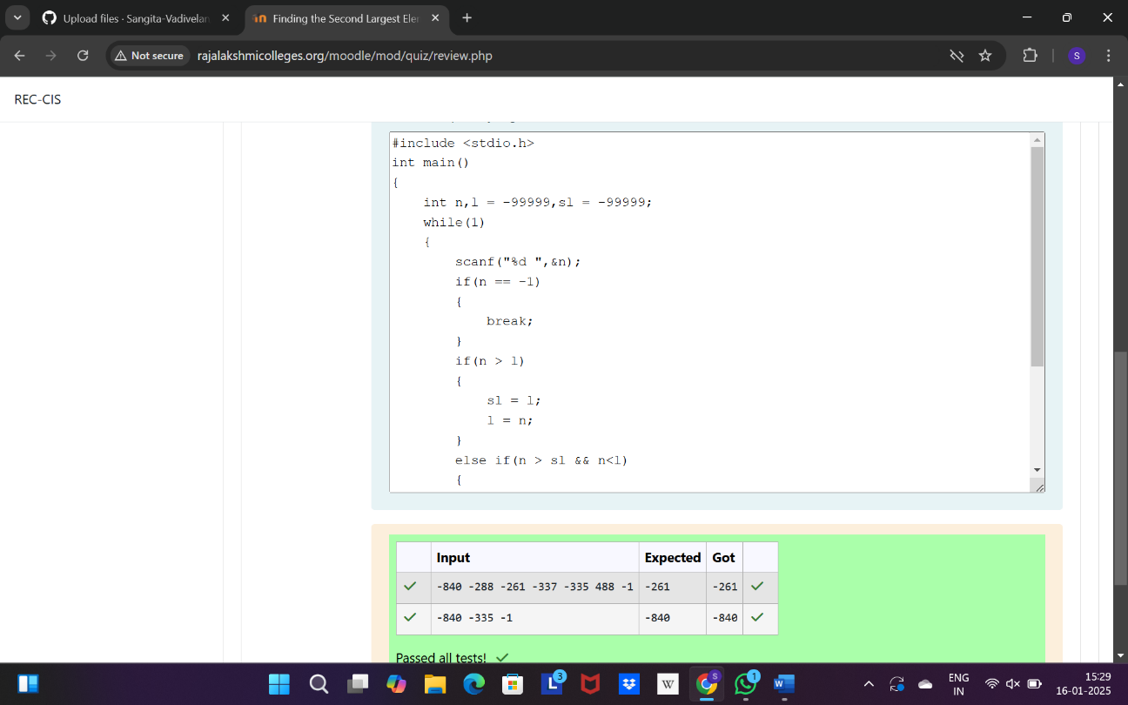

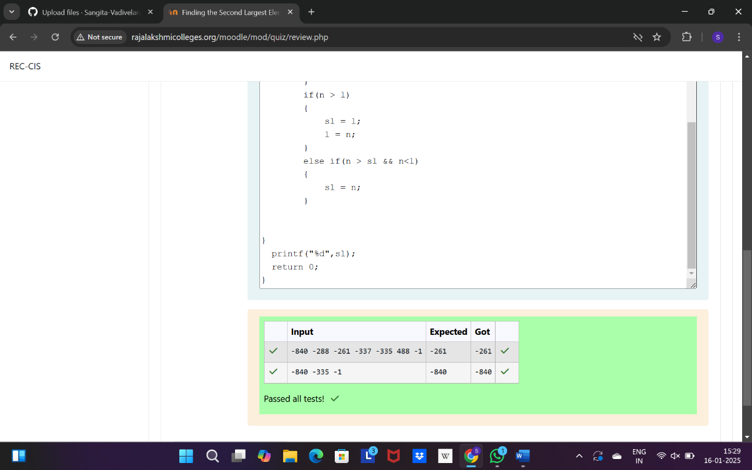

The lengths of the sides of a triangle X, Y and Z are passed as the input. The program must print the smallest side as the output.

**Input Format:**

The first line denotes the value of X.  
The second line denotes the value of Y.  
The third line denotes the value of Z.

**Output Format:**

The first line contains the length of the smallest side.

**Boundary Conditions:**

1 <= X <= 999999  
1 <= Y <= 999999  
1 <= Z <= 999999

**Example Input/Output 1:**

Input:  
40  
30  
50

Output:  
30

**Example Input/Output 2:**

Input:  
15  
15  
15

Output:  
15

